Northover's VT
sponsored by Rudy Project

present their

Easter 10 Mile Time Trials
Event Sponsored by:
Yellow Ltd
Rudy Project

Monday 5th April 2021

Course S26R/10

(Promoted for and on behalf of Cycling Time Trials under
their Rules and Regulations)

IN THE INTEREST OF YOUR OWN SAFETY
Cycling Time Trials and the event Promoters strongly advise you to wear
a HARD SHELL HELMET that meets an internationally
accepted safety standard.

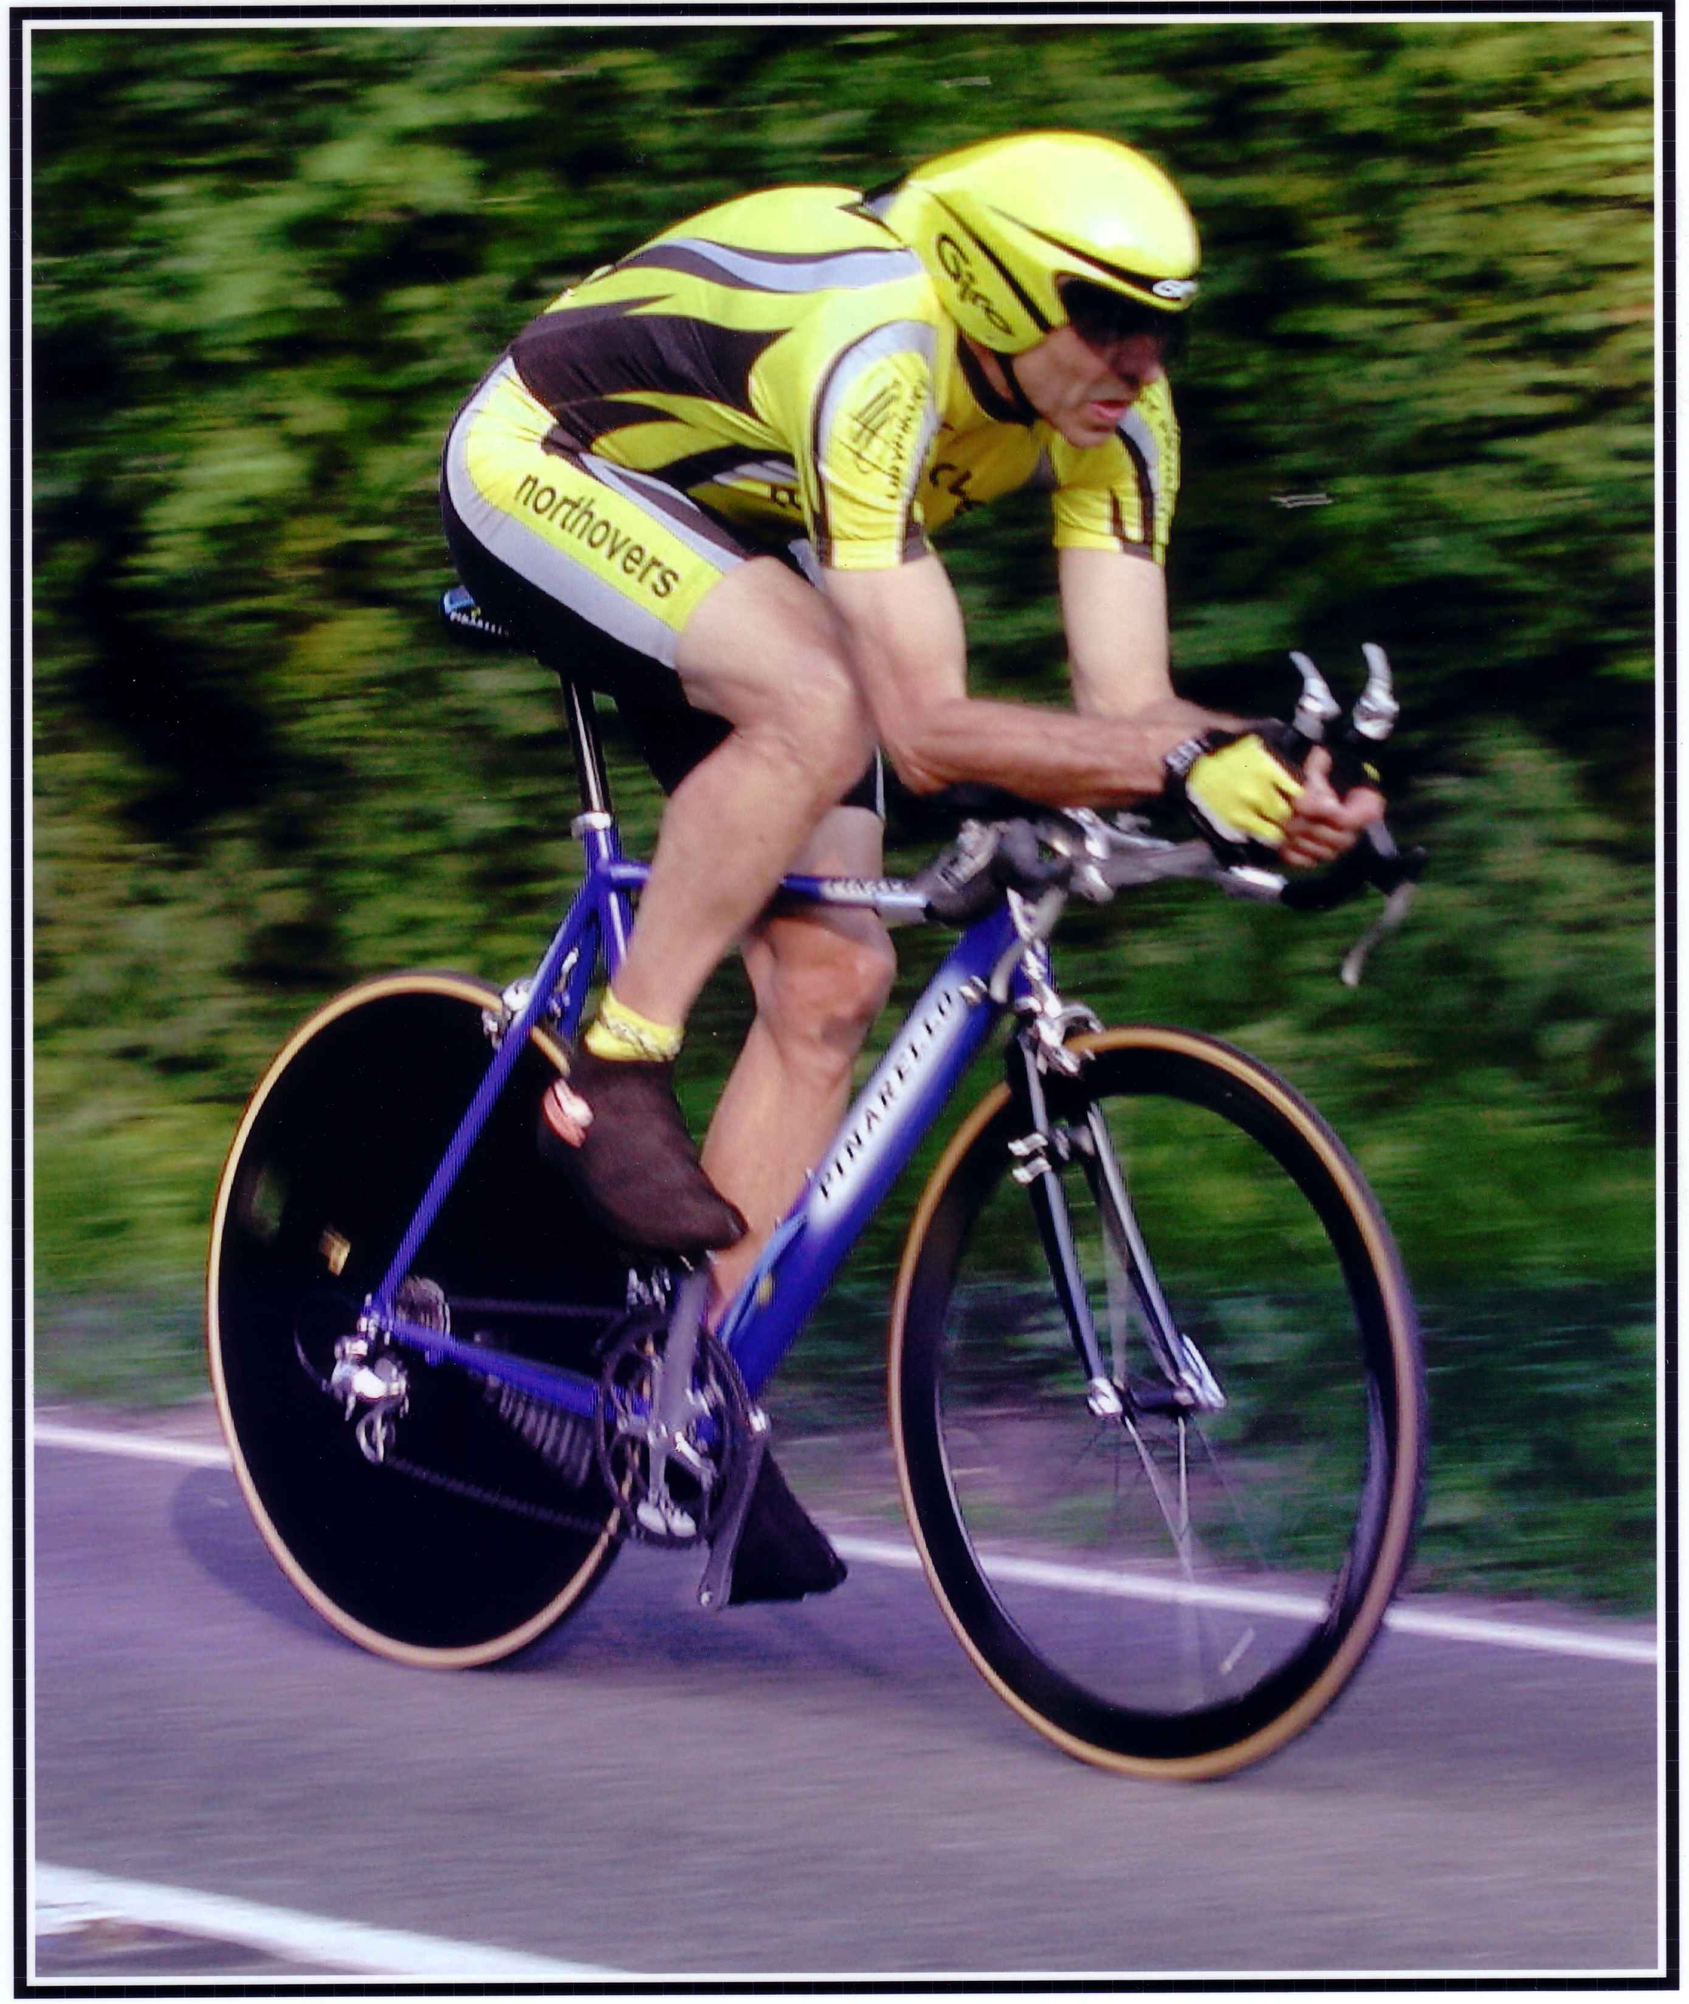

This Northover’s VT 10 Mile Solo & 2up TT is organised in memory
of our team-mate and good friend Bob Redrup who passed away unexpectedly on 26 September 2003 whilst on a training ride with the team prior to the
Duo Normandy in Marigny, France.
Easter Solo & 2Up 10 Mile Time Trial

Course Details: S26R/10

Start on old A30 at the lay-by approximately 200 yds East of Pattersons Cross, Feniton at a point 127 yds prior to the splay end of the lay-by. Proceed eastwards to go under the railway bridge and join the new A30 (care). Continue on the A30 to pass Honiton and at SECOND SLIP ROAD filter left (M) into slip road signed Dorchester. Crossover A30 and turn right (M) to re-join the A30 westbound. Pass Honiton and at slip road signed Otter Nurseries filter left to leave the A30, Give Way at base of the slip road and turn left onto the old A30 (M). Finish at a point 101 yds prior to the old railway bridge and some 200 yds short of the start point.

Please Call Number Loud and Clear When Finishing

Event HQ Organiser Timekeepers

Feniton Village Hall Tom Cox Andy Greatwood
Feniton, Nr Honiton 54 Graham Way Ray Pollard
Devon Cotford St Luke
Somerset TA4 1JG

Prize List Men- Solo
1st £30 – Steve Lampier - Saint Piran19:42
2nd £25 – Frederik Scheske – Ribble Weldtite Pro Cycling 19:45
3rd £20 – George Kimber Spirit Tifosi -RT 20:31

Prize List Ladies
1st lady £30 – Natalie Grinzer – CAMS-Tifosi 23:01
2nd Lady 25 – Catherine Hilton Sid Valley CC 26:02
3rd Lady 20 – Gemma Waterjohns Somerset RC 26:25

1st Vet 40+ £10 Andrew Perkins Mid Devon CC 21:14
1st Vet 50+ £10 Gavin MacDougall RNRMCA 21:27
1st Vet 60+ £10 Roger Sheridan North Devon Whlrs 23:12
1st Junior £10 – Quentin Crowley Farn & Camb CC 21:15

Prize List – 2up
1st Club Team or Composite £30
J Kimber SPIRIT TIFOSI RT & J Dallayn Exeter Whlrs – 20:12

2nd Club Team or Composite £25
T Rebhan & S Broomfield Plymouth Corinthians CC 22:17

3rd Club Team or Composite £20
N Ball & M Daniels Team Tor 2000/ Kalas

NB: One Rider one Prize

Note prize winners please send me your bank details. I will arrange transfer as we are currently unable to a have prize presentations or results at the event due to Covid at this stage.
As an organiser it’s always difficult to know if you have done the right thing.
Last night I looked at the weather and thought oh NO! In the end we actually had the warmest early morning in the area for most of the week, unfortunately it didn’t get any warmer. But it was dry - almost!

Anyway, firstly congratulations to all the prize winners in both Solo and 2up events. Secondly to Steve for a good win over Frederick by just a few seconds, well done to both. Also to Jack and George in the 2up, who I think used the solo just to warm up for the 2up, so well done lads.

Can I also take the time to thank all my helpers who put themselves out for all of us today. Starting from the top Mrs O, Sally, Mike Rose, Gavin, Ken Robertson, Sue Gould, John Williams and of course timekeepers Andy Greatwood and Ray Pollard. Lastly to my wife Rosemary who supports me both me in the running of the event and on the day activities as well.

For information Mrs O had her camera out at the turn as well and as usual there are some great shots. These have been published by Ann on Facebook so take a look, she does the sport proud and it was great to have her there today.

